Samadipa Saha

Uma Sreeram

Brett Watanabe

Determining Potential Credit Risks from Loan Data

**Abstract**

Summary with goals and major findings

**Introduction**

When a customer wants to purchase something, but does not have the funds, they may go to a bank to get a loan. Banks charge interest on loans so it is in their best interest to loan money to customers as long as those customers pay them back. However, there are customers who do not pay back their loans and cause the bank to lose money. If banks can identify customers that are good or bad credit risks, they can be more selective about who they loan money to and save themselves money.

In this study, we use bank data from a German bank to identify customers who are good and bad credit risks. We use several classification techniques including logistic regression, support vector machines (SVM), k-nearest neighbors (KNN), decision trees, and random forests. We expect that logistic regression will provide valuable insights into the relationship of the response variable with the predicting variables and random forest will provide good predictability.

**Data**

This data came on the UCI Machine Learning Data Repository at the following url: <https://archive.ics.uci.edu/ml/datasets/Statlog+%28German+Credit+Data%29>

The dataset has 1000 rows with 21 columns. The original dataset has an unusual labeling system so we reformatted it to be human-readable.

We are using the following variables:

Response variable:

not_default - indicating if the person is good credit risk (1) or if the person is bad credit risk (0)

|  |  |  |
| --- | --- | --- |
| Predicting Variables | Type | Description |
| checking_balance | Categorical | Indicates if the checking balance is 200 DM or not |
| months_loan_duration | Quantitative | Duration of the loan in months |
| credit_history | Categorical | Credit status for if the customer has paid their debts |
| purpose | Categorical | Purpose for the loan |
| amount | Quantitative | Amount of the loan (DM) |
| savings_balance | Categorical | Ranges of money in savings account |
| employment_length | Categorical | Ranges of years employed |
| installment_rate | Categorical (Quantitative) | Installment rate in percentage of disposable income |
| personal_status | Categorical | Gender and marital status |
| other_debtors | Categorical | None, guarantor, or co-applicant |
| residency_history | Categorical (Quantitative) | Years at current residence |
| property | Categorical | Type of residence |
| age | Quantitative | Age of customer |
| installment_plan | Categorical | None, bank, or stores |
| housing | Categorical | Rent, own, or for free |
| existing_credits | Categorical (Quantitative) | Number of existing credits at bank |
| dependents | Categorical | Number of people being liable to provide maintenance for |
| telephone | Categorical | If customer has a telephone |
| foreign_worker | Categorical | If customer is a foreign worker |
| job | Categorical | Job type |

***Exploratory Data Analysis:***

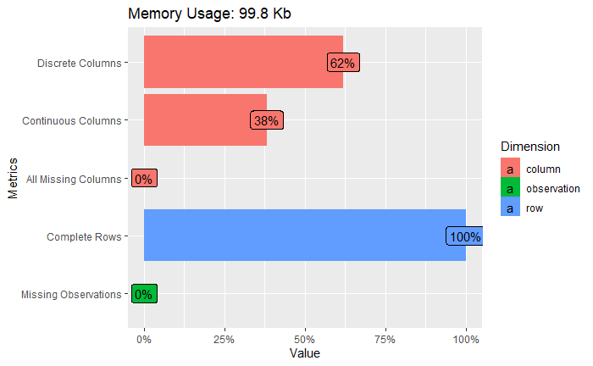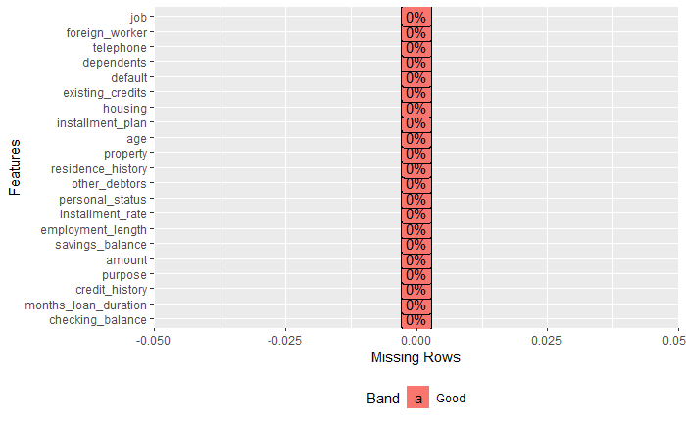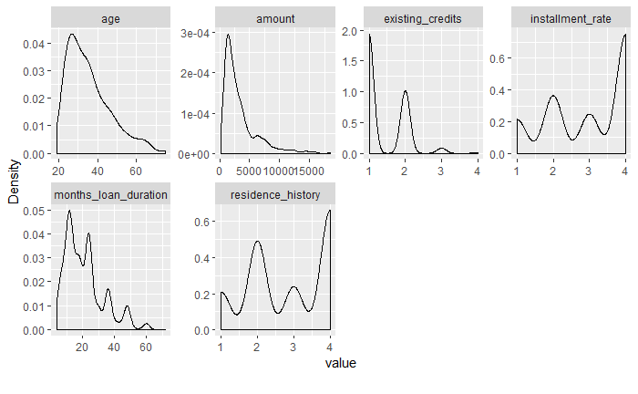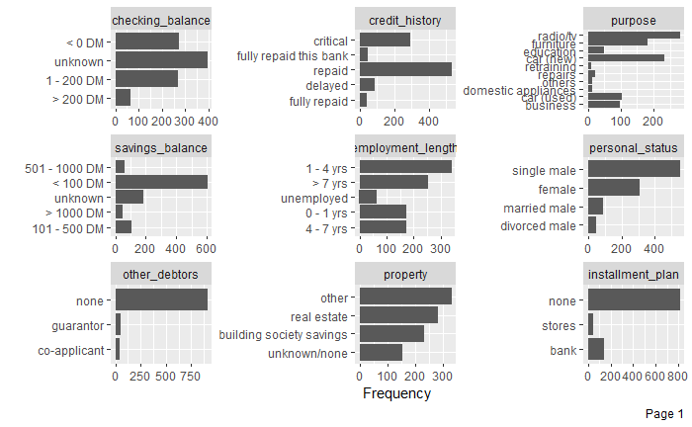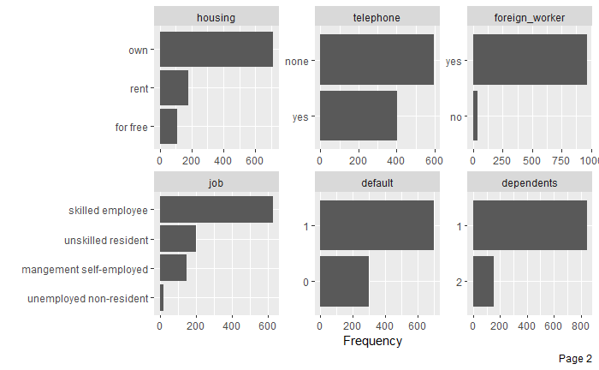

Inferences:

* 70% of the rows in our dataset has information about people classified as good credit risks.
* The dominant demographic includes:
  + Single Males
  + Employment length: mostly less than 1-4 years. A significant portion with experience greater than 7 years
  + Highly skilled
  + Foreign workers
  + Fully repaid their previous loans
* Majority of the population sampled are not enrolled in any installment_plan,have dependents and have their own housing
* Most of the loans taken in the past by the people sampled were taken individually (no co-debtors/co-applicants cited)
* Purpose of the loans availed so far were majorly for radio/tv and new cars.
* Majority of the loans availed were for amounts in the range of 0-5000(units)
* Number of existing_credits (lines of credits) are mostly 1 or 2
* Studying the correlation matrix of continuous variables, we can conclude that:
  + Amount has an obvious higher correlation with month_loan_duration as higher the loan, it would take longer to pay off
  + Month_loan_duration also has a slight negative correlation with our response variable ‘default’, showing that most loans defaulted were higher in month_loan_duration.
  + There is a slightly positive correlation between age and residence history (Older the person, more likely they are to have lived in a place for a long time)
  + Interestingly, installment_rate has a slight negative correlation with amount

This is probably due to the bank offering more attractive rates to people availing loans of a higher amount.

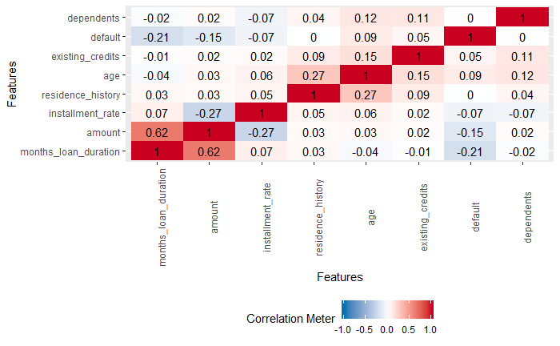

* We also plotted boxplot for the quantitative variables against the response variable.
* The boxplot of amount vs response shows that the mean amount for default (0) is greater than the mean amount for no default which indicates individuals taking higher loan amounts are more likely to default than individuals taking lower loan amounts.

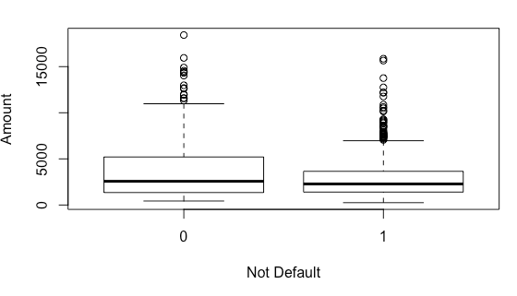

* The boxplot of age vs response shows that the mean age for default (0) is lower than the mean amount for no default which indicates that younger individuals are more likely to default.

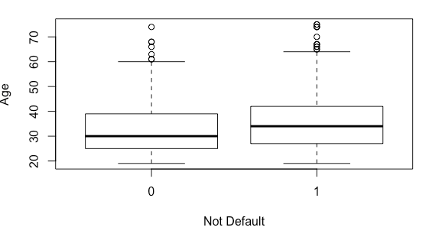

* The boxplot of month_loan_duration vs response shows that the mean loan duration for default (0) is higher than the mean loan duration for no default which indicates that individuals taking loan for a longer duration are more likely to default.

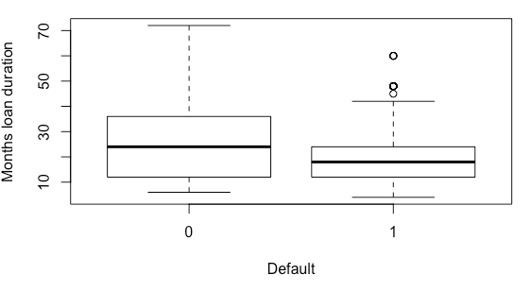

**Methods used and Model Assumptions**

We classified customers as good or bad credit risks using logistic regression, decision trees, random forest, support vector machines(SVM), and the k-nearest neighbors algorithm (KNN). We also applied variable selection to several of the models to see if that improved classification rates. Our data was split into a training set and a test set. The training set consisted of 80% (800 rows) of the original data and the test set consisted of 20% (200 rows). The training set was used to train our models and the test set was used to calculate the classification accuracy.

*Logistic Regression*

Logistic regression is a supervised learning algorithm used for classification. It models the probability of success given predictors and it links the probability of success given predictors to the predicting variables using a non-linear logit link function.

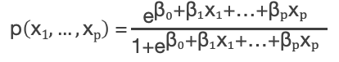

We started with logistic regression because it is simple and easier to interpret. We can see the relative importance of each factor in the model visually.

We tried several models for logistic regression as summarized below.

1. We fitted logistic regression model to the full dataset, after factoring the categorical variables into dummy variables.

* Only 15 out of the 50 total variables (including dummy variables) were significant at 0.05 level significance. The p-value for the test of overall regression was 0, which indicates that at least one variable is significant in explaining the variability of the response.
* We performed goodness of fit tests to verify if the logit link function was appropriate fit for the data.Using both pearson and deviance residuals, the p-value was greater than 0.05, hence we do not reject the null hypothesis of good fit.
* Performing the test for overdispersion, the over-dispersion metric was less than 2. Thus there was no over-dispersion.
* The histogram plot and qq plot of the residuals showed a bimodal distribution, indicating an important predicting variable or interaction term was missing from our data.

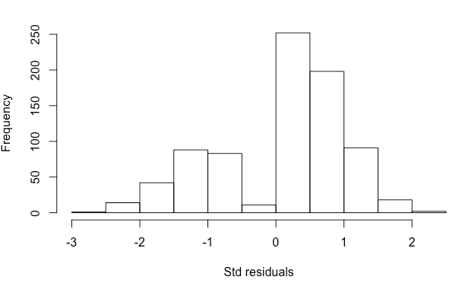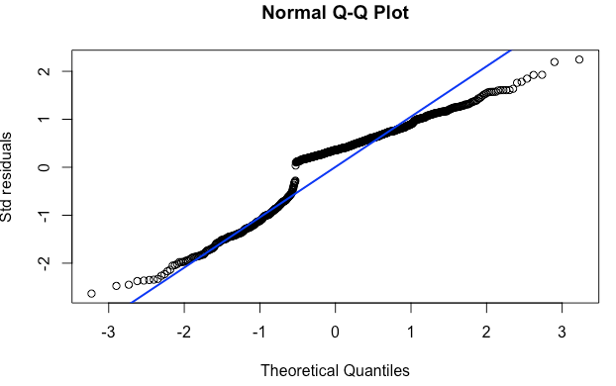

* The residual plots against the predictors for some variables namely age,amount,residence history, working credits,months loan duration and installment rate are distributed equally equally about the zero line.

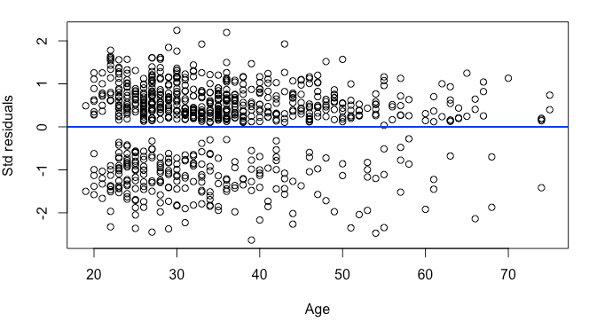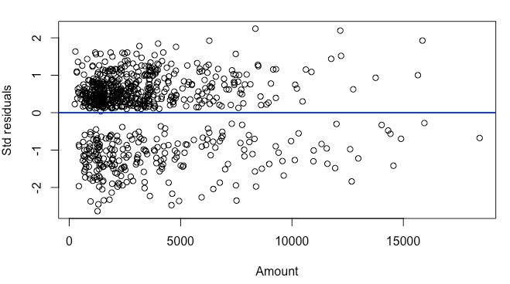

* However, categorical variables like telephone, foreign worker, job, property, installment plan, housing, checking balance, purpose ,employment length, personal status, other debtors have the median residual value of different categories on one side of the zero line indicating some bias

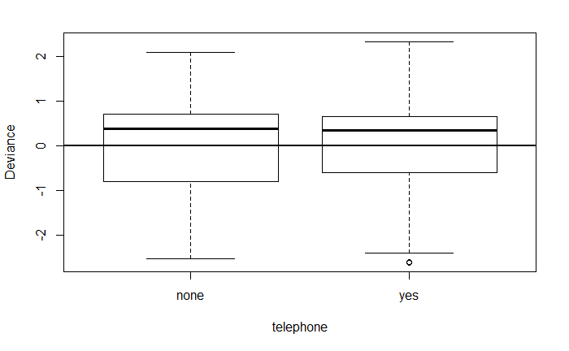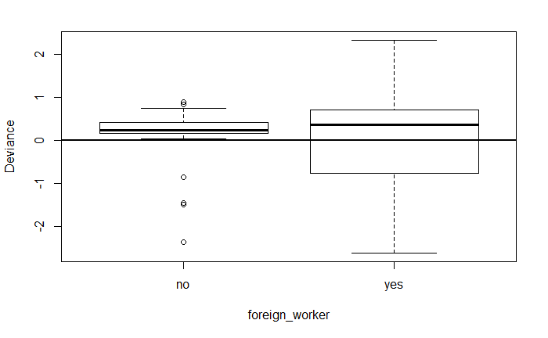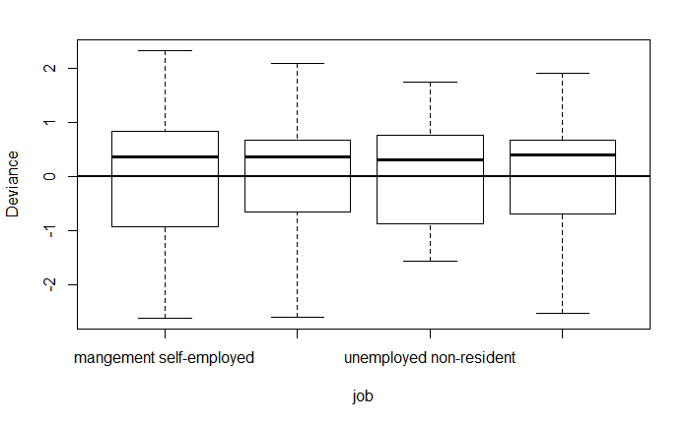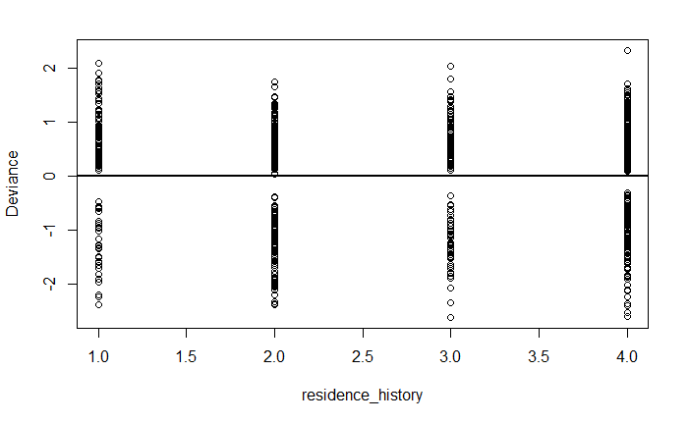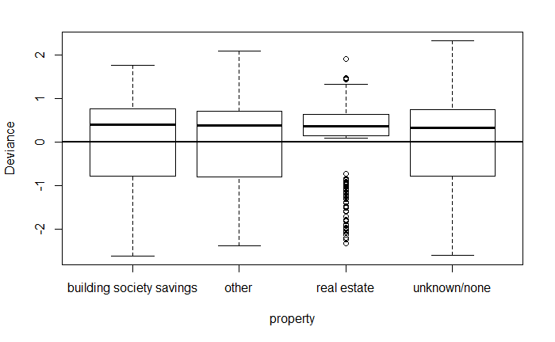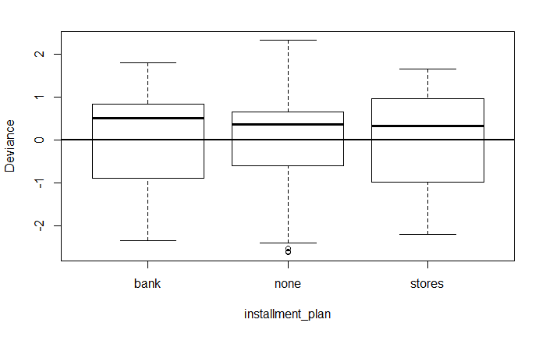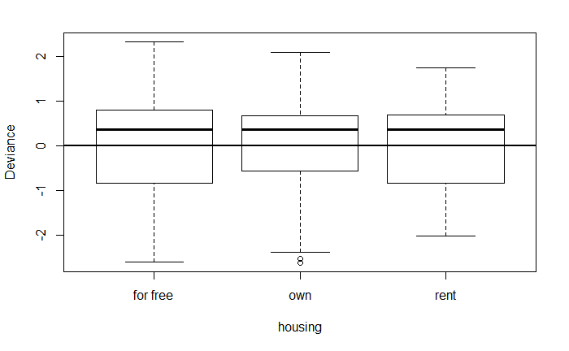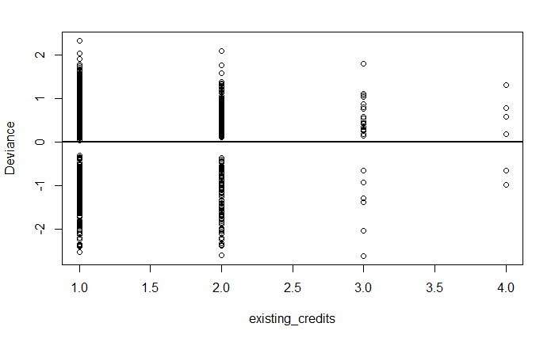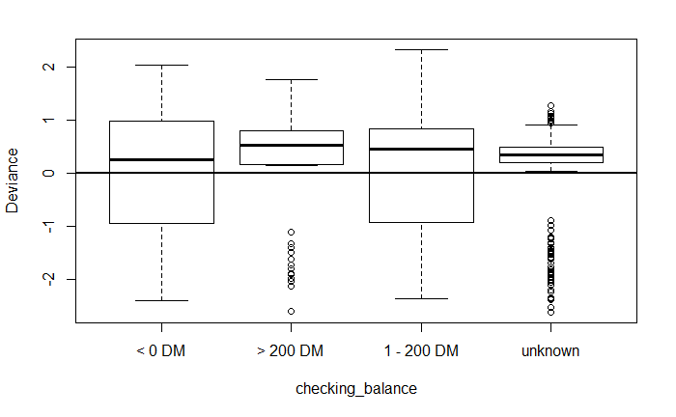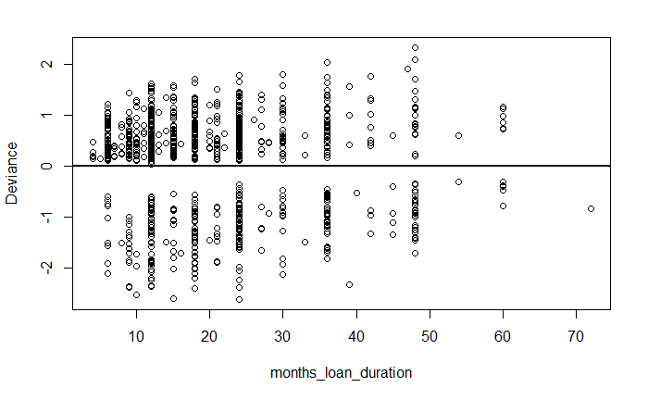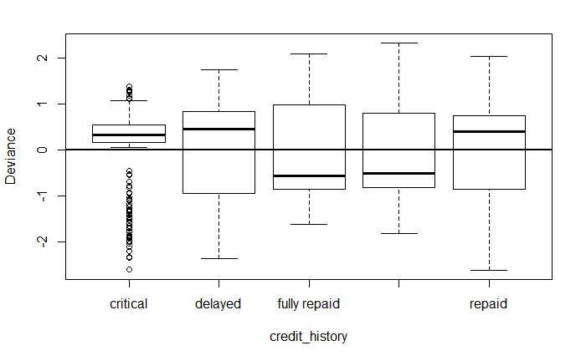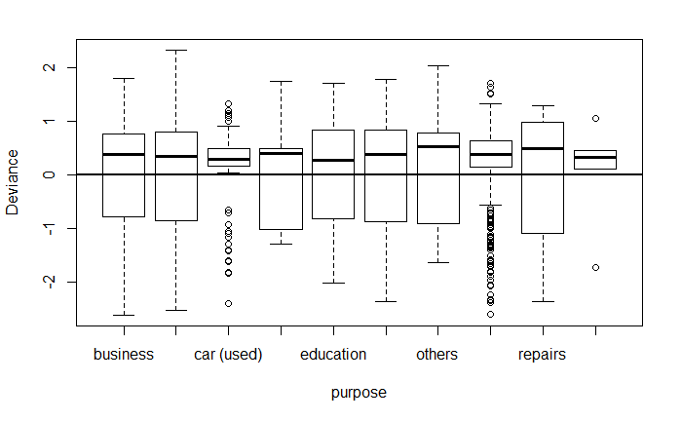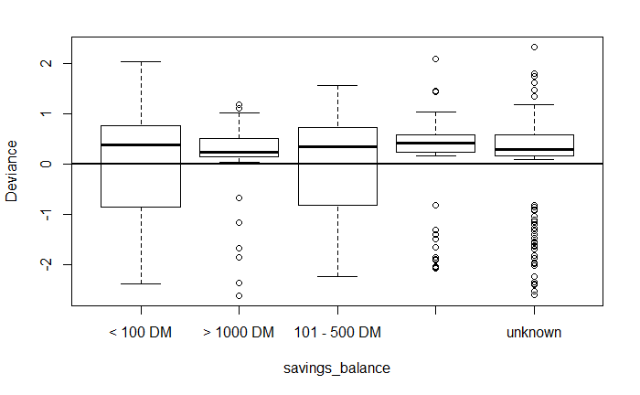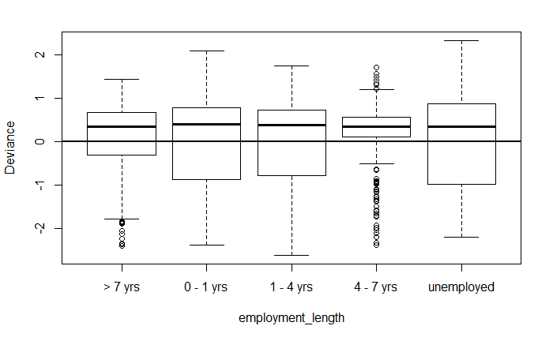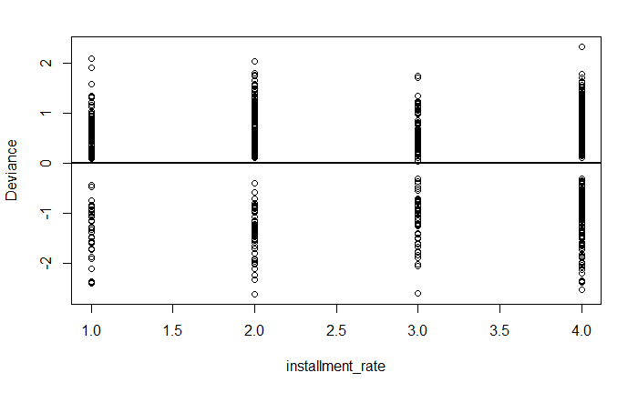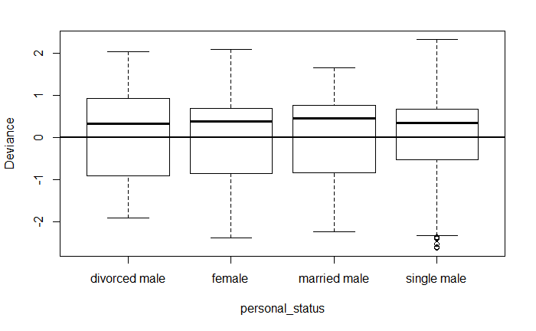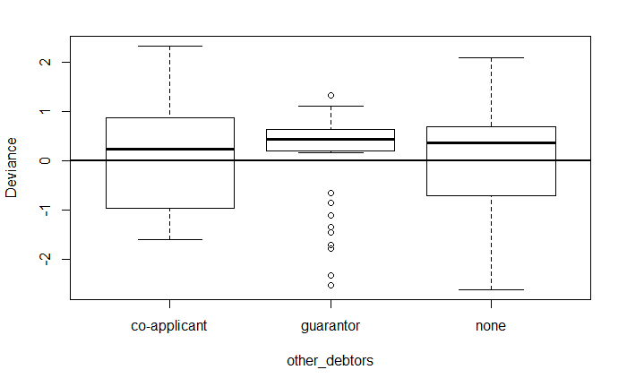

1. Plotting the cook’s distance for each observation provided us with the outlier observations. We fitted our second model by removing the outlier observations from our dataset. 23 out of 50 variables are significant at the 0.05 significance level.

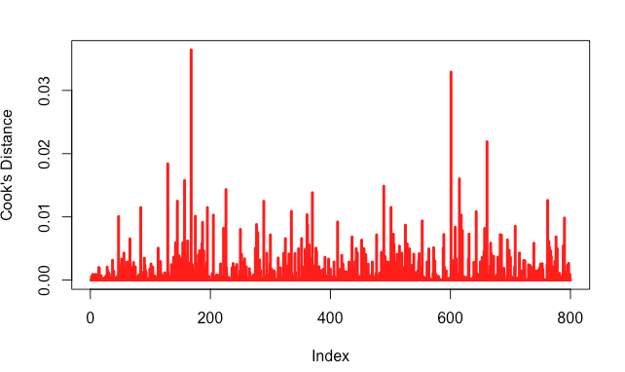

1. We fitted the next model with the probit link function on all the training data and compared the model performance against the full model fitted earlier with the logit link function.
2. The fourth model was fitted using forward stepwise regression. This was done to reduce the large feature set and to avoid possible multicollinearity among the predicting variables. For forward stepwise regression, we start with a model with only the intercept and add variables incrementally to the model which minimizes the criterion value. The criterion used is the sum of the prediction risk and the complexity penalty.

Three kinds of complexity penalty can be used.

* Mallow’s cp

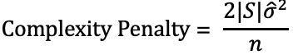

where |S| is the number of predictors and is the estimated variance based on the full model.

* Akaike Information Criteria (AIC)

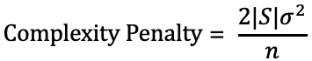

where is the true variance of the model which can be replaced with an estimate from the full model or submodel.

* Bayesian Information Criteria (BIC)



where is the true variance of the model which can be replaced with an estimate from the full model or submodel. BIC penalizes complexity most and is most preferred in model selection.

41 out of 50 variables were selected by the forward stepwise regression model. Out of the 41 selected variables, only 15 variables were significant at the 0.05 significance level.

1. The fifth model was fitted using the backward stepwise regression and a comparison was made between the variables selected using forward stepwise regression and backward stepwise regression.For backward stepwise regression, we start with a model with only the intercept and remove variables incrementally from the model which minimizes the criterion value. The criterion used is the sum of the prediction risk and the complexity penalty as discussed before in forward stepwise regression.
2. We tried to perform feature selection using lasso regression to optimize for the bias variance tradeoff. Lasso regression estimates the predictor coefficients by minimizing the penalized sum of squares errors. Numerical algorithms are used to estimate the coefficients as the there is no closed form solution.

The regression coefficient path of the lasso regression model was also plotted to visualize which coefficient enters the model early.

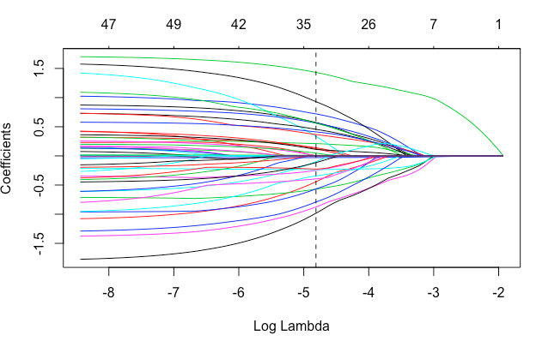

1. Next, we performed elastic net regression because it removes the limitation on the variables selected as imposed by lasso regression and also stabilizes the L1 regularization path. We performed elastic net regression with alpha = 0.5.

*Support Vector Machine*

A support vector machine (SVM) is a supervised learning model used for classification. The model represents each sample as a point in an Rn space in such a way that samples of a different category can be divided by a gap in that space. New samples that are on one side of that gap are classified as one category and samples on the other side of the gap are classified as another category. We used SVMs to classify customers as good or bad credit risks.

We created models that used several types of algorithms used for pattern analysis called kernels. We used linear, polynomial, Gaussian RBF, hyperbolic tangent, Laplacian, and Bessel kernels.

*K-Nearest Neighbors*

K-nearest neighbors algorithm is a classification method. When predicting the class of a new data point, it looks at that point’s k nearest neighbors in the data set’s feature space and assigns the data point the class that the majority of its neighbors have. We used k-nearest neighbors to classify customers as good or bad credit risks with k being the odd integers between 3 and 25.

*Decision Tree*

A decision tree is a decision support tool that uses a tree-like graph or model of decisions and their possible consequences.

We got a flowchart-like structure in which each internal node represents a “test” on an attribute, each branch represents the outcome of the test, and each leaf node represents the probability of default. As the result we obtained a vector which was the probability of the record being a good credit risk(1).

*Random Forest*

Random forest, like its name implies, consists of a large number of individual decision trees that operate as an [ensemble](https://en.wikipedia.org/wiki/Ensemble_learning). Each individual tree in the random forest spits out a class prediction and the class with the most votes becomes our model’s prediction.This assigns a probability of a record being a good credit risk(1) after polling all its candidate trees.

**Results**

Logistic Regression

We fitted each of the above discussed logistic regression model on the training set and evaluated the model performance on the testing set. The prediction returned with probabilities of each observation being in class 1, which were then converted to class labels by using the threshold value r, where the classification error rate was minimized. All observations with probabilities > r are classified as 1 (good credit risk) and <= r as bad credit risk. The following table shows the performance of various logistic regression models fitted on the training data.

|  |  |  |  |  |
| --- | --- | --- | --- | --- |
| **Model** | **Accuracy** | **Sensitivity** | **Specificity** | **AUC** |
| Full Model | 0.79 | 0.8540146 | 0.6507937 | 0.7359 |
| Full Model w/o outliers | 0.79 | 0.8776978 | 0.5901639 | 0.7339 |
| Full Model with probit | 0.79 | 0.8561151 | 0.6393443 | 0.7477 |
| Forward step model | 0.79 | 0.8776978 | 0.5737705 | 0.7257 |
| Backward step model | 0.79 | 0.8776978 | 0.5737705 | 0.7257 |
| Lasso | 0.79 | 0.8201439 | 0.7213115 | 0.7707 |
| Elastic Net | 0.77 | 0.8417266 | 0.5901639 | 0.7159 |

From the table above we can see that the overall accuracy is almost similar across all the models. But an interesting fact to note is that 1. the specificity for the **lasso** regression model is much higher compared to the other models. Specificity corresponds to the true negative rate. In our case the true bad risk rate. This is particularly important if wrongly identifying a bad credit risk individual is much more costlier to the the loaning bank than wrongly classifying a good credit risk individual as bad credit risk. Also, 2. the area under ROC curve for the model fitted with lasso regression is higher than the other models.

The classification error rate for various threshold values r for lasso regression model is plotted in figure (i) below :

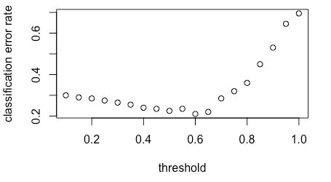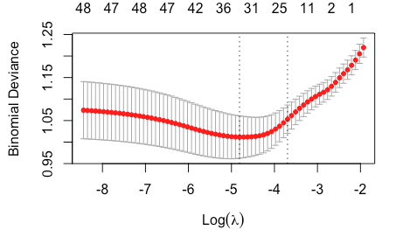

(i) (ii)

The plot (ii) above displays the cross-validation error according to the log of lambda. The left dashed vertical line indicates that the log of the optimal value of lambda is approximately -5, which is the one that minimizes the prediction error. This lambda value will give the most accurate model. The exact value of lambda was found to be **0.00813013**.

The confusion matrix for predictions using lasso regression model on the test set is given below. Please not that 0 corresponds to bad credit risk and 1 corresponds to good credit risk.

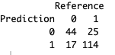

SVM

Of all the kernels we used, the linear kernel performed the best.

|  |  |  |  |  |
| --- | --- | --- | --- | --- |
| **Kernel** | **Accuracy** | **Sensitivity** | **Specificity** | **AUC** |
| Linear | 0.730 | 0.8705036 | 0.4098361 | 0.6401698 |
| Polynomial | 0.730 | 0.8705036 | 0.4098361 | 0.6401698 |
| Laplacian | 0.710 | 0.8705036 | 0.3442623 | 0.6073829 |
| Gaussian RBF | 0.675 | 0.8057554 | 0.3770492 | 0.5914023 |
| Hyperbolic tangent | 0.660 | 0.7625899 | 0.4262295 | 0.5944097 |
| Bessel | 0.535 | 0.6762590 | 0.2131148 | 0.4446869 |

KNN

Of all the k’s that we used, the highest accuracy was returned when k = 17. When k = 17, the accuracy, sensitivity, sensitivity, and AUC are 0.745, 0.9209, 0.3443, and 0.6326 respectively.

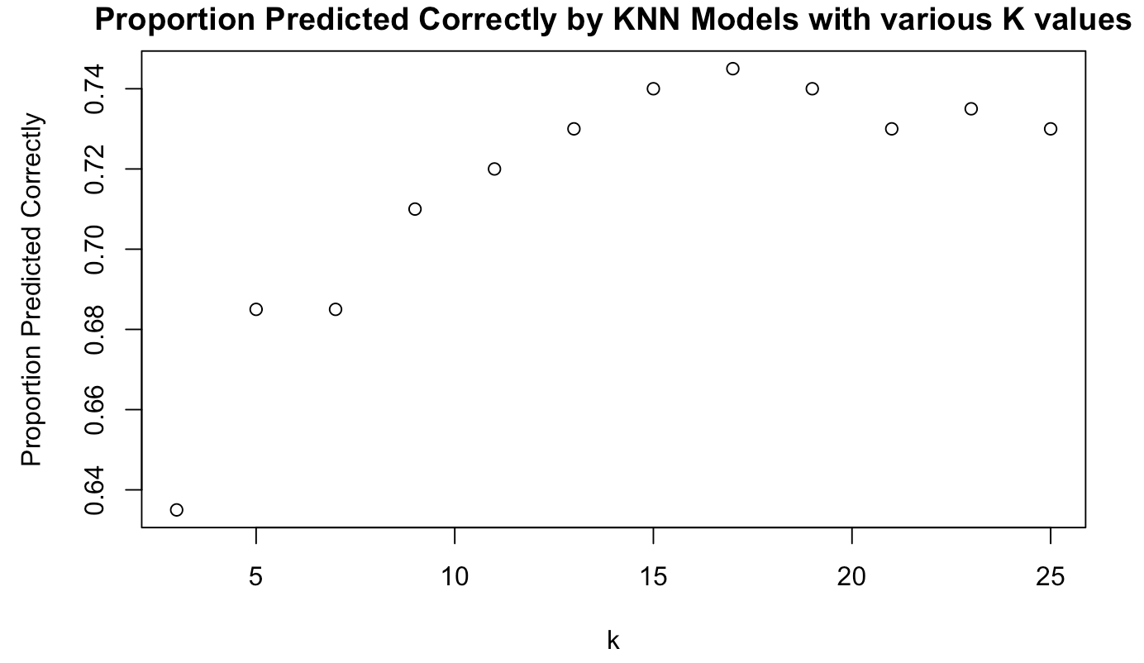

Decision Tree

With an initial fit, we obtained a decision tree with a depth of 6. We then performed cross-validation on the training data to try different options of depth. We checked the deviance residuals at different options and found that we obtain the least residuals at depth 3.

Deviance at different depths:

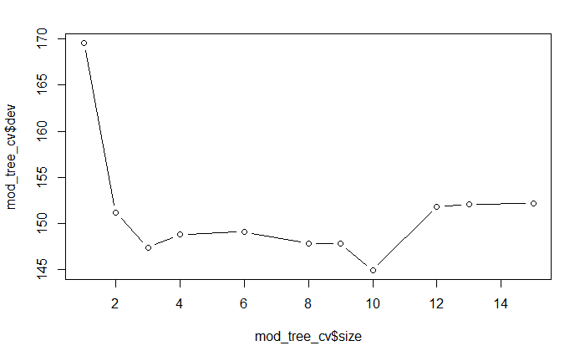

Pruned tree:

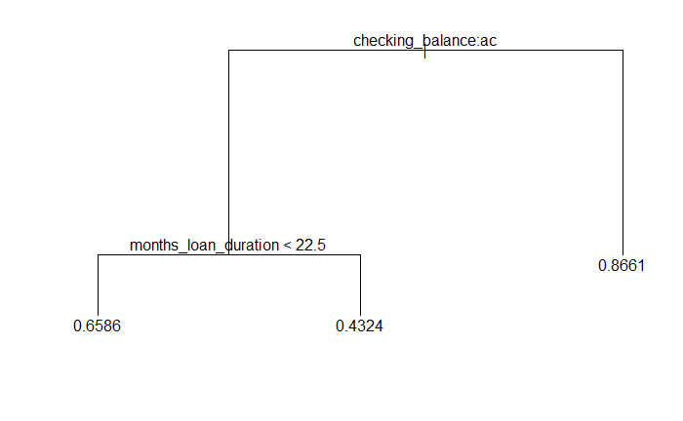

We then pruned the tree and calculated accuracy on the testing data at different thresholds.

We got the highest accuracy of 72.5% at threshold 0.5

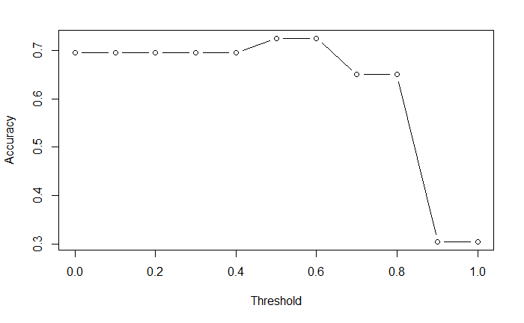

Sensitivity: 0.8345324

Specificity: 0.4754098

AUC: 0.655

Random Forest

While fitting the random forest, we plotted the node purity to check which are the attributes chosen by most decision trees within the forest to form the splits. We see amount, checking balance, purpose and months loan duration to be good candidates. Two of these (checking balance and months loan duration) were also observed in our previous decision tree. The candidate trees form the splits in different combinations of the attributes and the final classification is determined by polling.

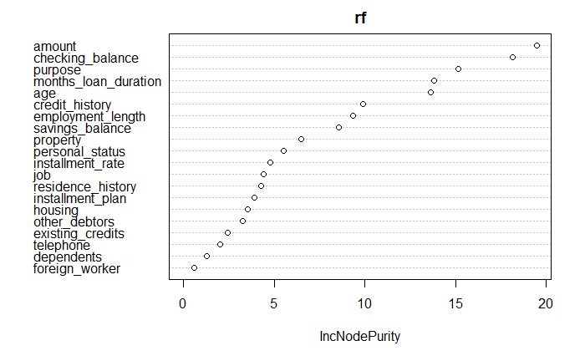

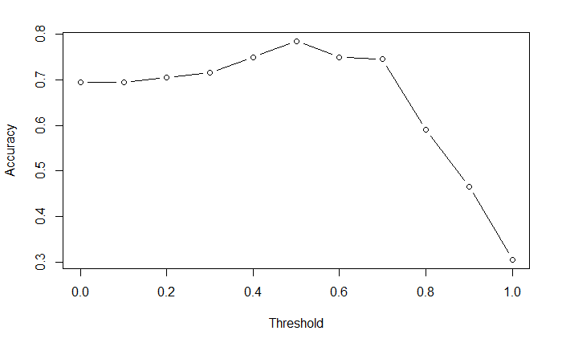

We got the best accuracy of 78.5% when the threshold was 0.5

Sensitivity: 0.9496403

Specificity: 0.4098361

AUC: 0.6797

**Discussion**

Of all the models we tried, Random Forest performed the best. This could be because random forest classifies each record in multiple ways using different combinations of the predictor variables that aid in decision making the most. In a way it tries to consider all possibilities of what could be important in making a decision about whether a customer is a good or bad credit risk.

There are several things that we could try in future studies to improve our classification. In this study, we only had 1000 data points which is not that many. We may get better results if we get a larger data set. When doing logistic regression, our data did not meet the assumptions needed to make inferences. Notably, we found a bimodal distribution in the model’s residuals. If we find a dataset with more predictors, we may be able to find one that can explain the bimodality and allow us to make inferences.